**Assignment 5- Data cleaning and Transformation and Ranking Functions**

**Data cleaning and Transformation**

Data cleaning focuses on identifying and correcting errors in the dataset, while data transformation involves shaping the data to make it suitable for analysis or modelling. Data cleaning and transformation are crucial steps in the data preparation process, which is essential for effective data analysis and provides us a better understanding of data.

**Some SQL commands used for data cleaning and transformation are:**

* **SELECT**
* **UPDATE**
* **DELETE**
* **ALTER**
* **DROP**
* **FILTER**
* **MODIFY**
* **SET**

**Ranking Functions**

* **Rank()**

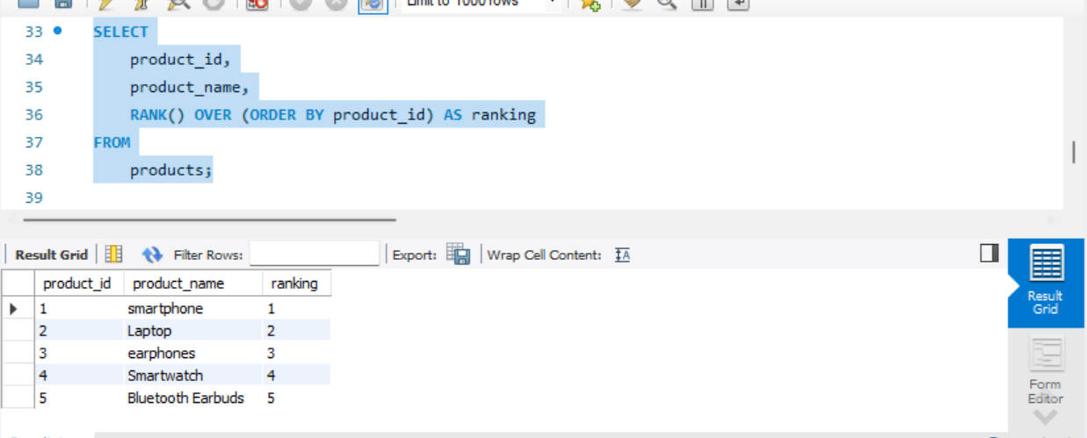

* **Dense_Rank()**

* **Row_number()**

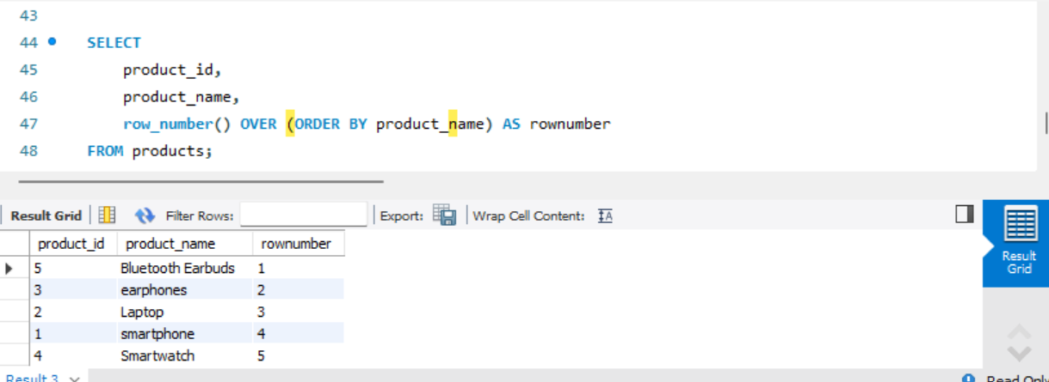

**Stored Procedure**

* **For creating procedure**

DELIMITER //

CREATE PROCEDURE GetAllEmployees()

BEGIN

SELECT * FROM customer;

END //

DELIMITER ;

* **For calling Procedure**

CALL GetAllEmployees;

